

# Guide-Setup WinSCP for secure file transfers to server

## Web Application Development COP3834

## Professor Navarro

This Windows application supports SCP, FTP, and secure file transfers with private keys in a gui.

Step 1: Download WinSCP and install following prompts

[Downloading WinSCP-5.19.2-Setup.exe :: WinSCP](https://winscp.net/download/WinSCP-5.19.2-Setup.exe) Program is not needed on Mac.

Step 2: Open WinScp and select Session Menu/Sites/Site Manager

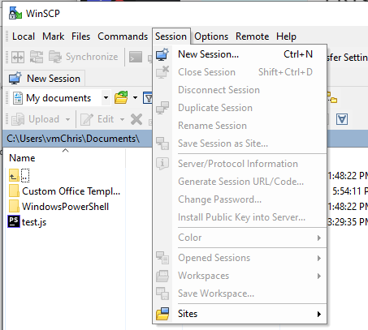

Step 3: Create a new Site to connect to AWS EC2 instance as below (change host name):

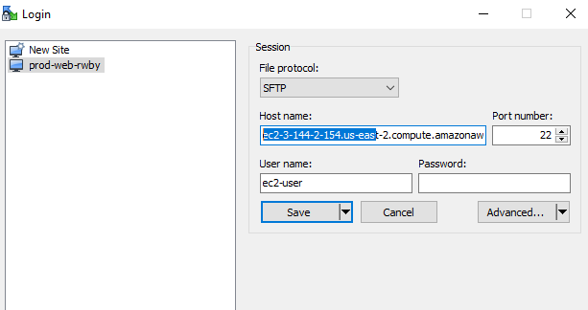

Step 4: Elevate privileges to directories like /var/www/html by updating the Shell setting. Select Advanced/Shell and change the Shell attribute from “Default” to “sudo su –“ Graphical user interface, text, application

Step 5: While in Advanced settings, Select SSH/Authentication/ and add private key file from AWS

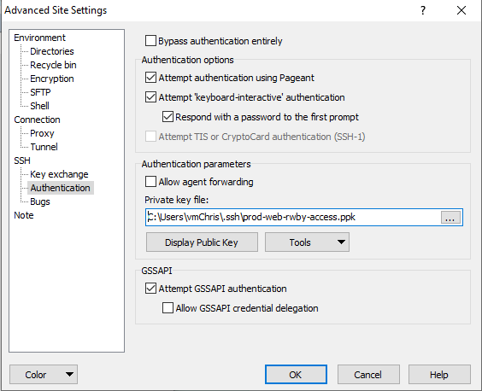

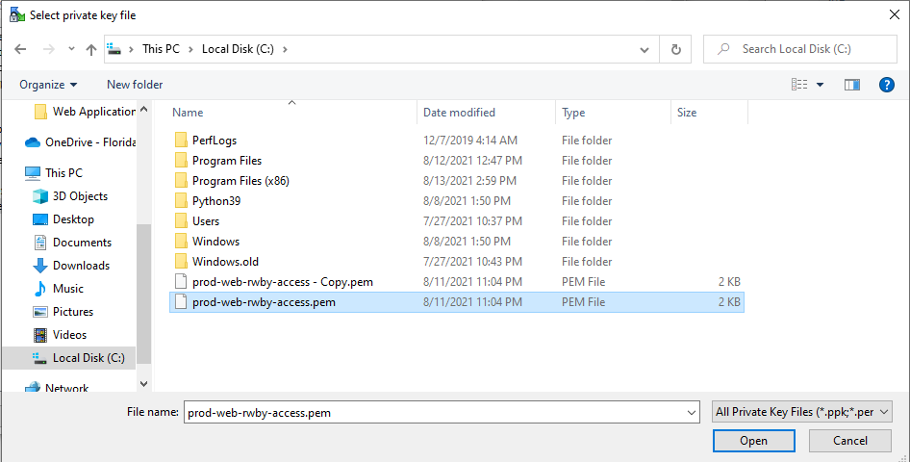

Step 6: Click OK to convert pem file to putty format of ppk

Note that this ppk file can be used by Putty as well since Putty doesn’t read pem files.

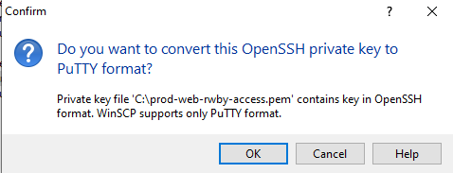

Be sure to save your site in the Site Manager.

Step 7: Log into your new site in WinSCP

The first time you login, you will need to agree to security prompt

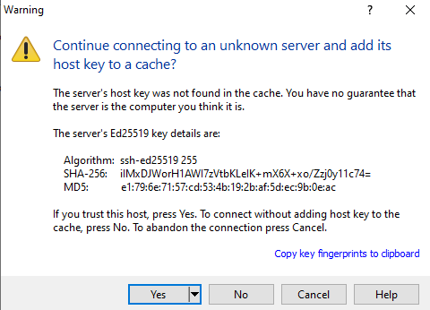

Successful log in will display local directory on left pane, with remote AWS server in the right pane.

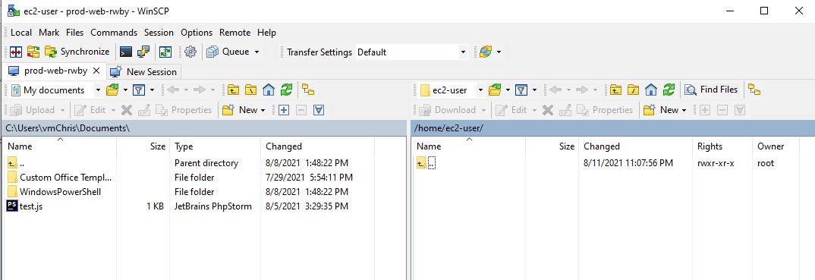

This supports drag and drop.

Step 8: Try to add a .txt document from your desktop to the EC2 server.

Also test copying a file from the EC2 back to your desktop.